Support Web

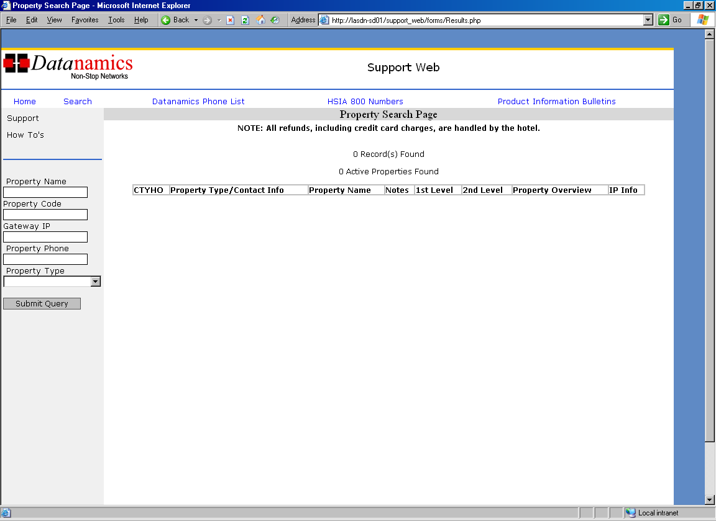

Property lookup

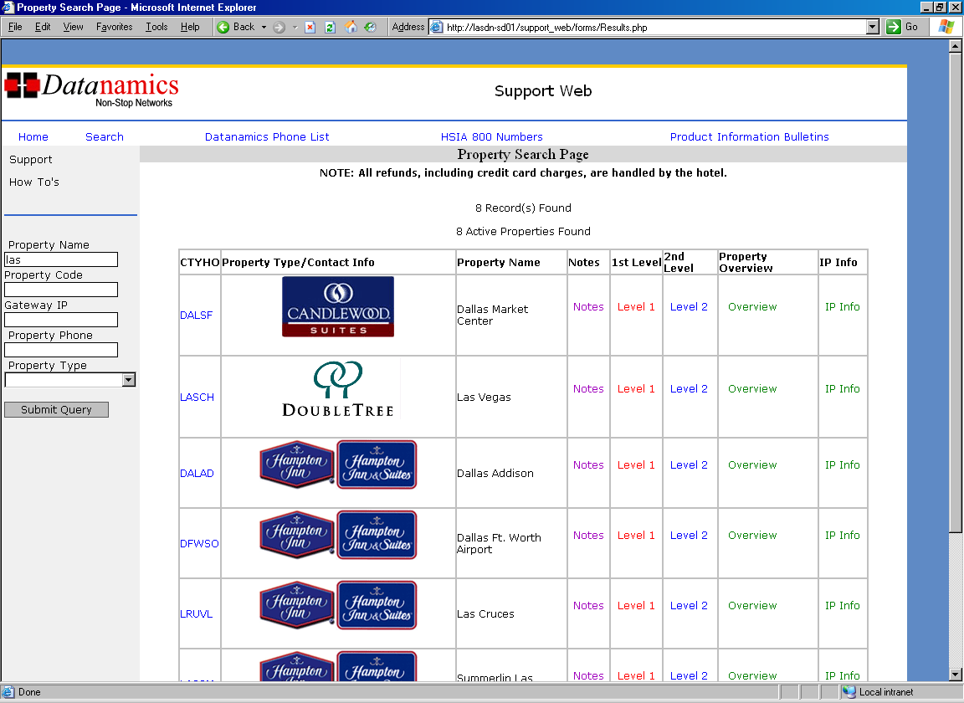

When looking up a property you can search by Property Name, Property Code, Gateway IP, Property Phone, and the Property type.

Property Name – You can search by the city or the name of the hotel.

Property Code and Gateway IP – These search fields are use by 2nd level.

Property Phone – Search by the phone number of the property.

Property Type – Pull up listings by the property type (IE DoubleTree, Hampton Inn, Hilton, Holiday Inn)

Property Pages

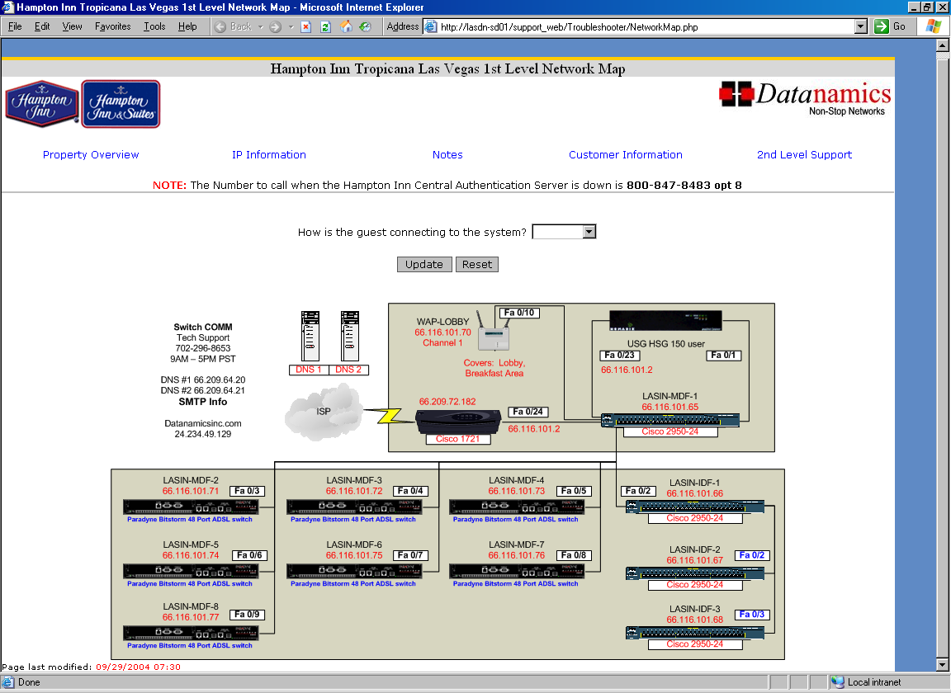

The property page shows the Network map for the hotel. As a level one you will not be able to access the switches, WAP’s, and Routers. You can access the USG, BBSM, IP3, or Solution IP box. On most property pages if you click on the router it will bring back ping results.

The next few pages will show the following links that are found on the property page:

- Property overview

- IP Information

- Notes

- Customer Information
Property Overview

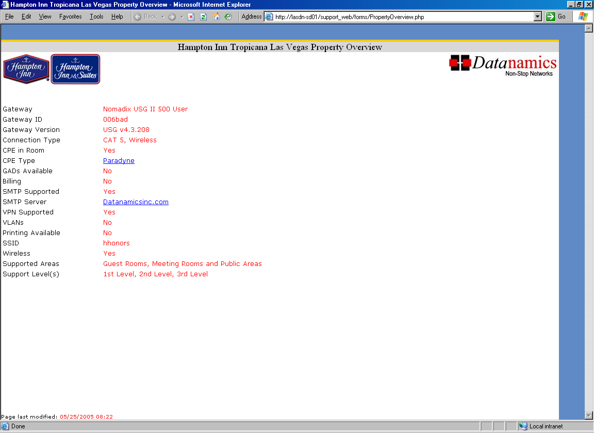

On the Property Overview page you will find the following:

- What type of network the hotel has. (IE Wired, Wireless, Or both)

- What type of CPE is available at the property.

- If GAD’s are available and if so how many the hotel has in stock.

- If there is billing at the hotel, How much it is, and who does the billing. (IE 11 wireless or PMS)

- The SMTP server address for the hotel.

- If it is a wireless hotel the name of the SSID.

- The areas of the hotel that are supported and the levels of support we offer for the hotel.
IP Infromation

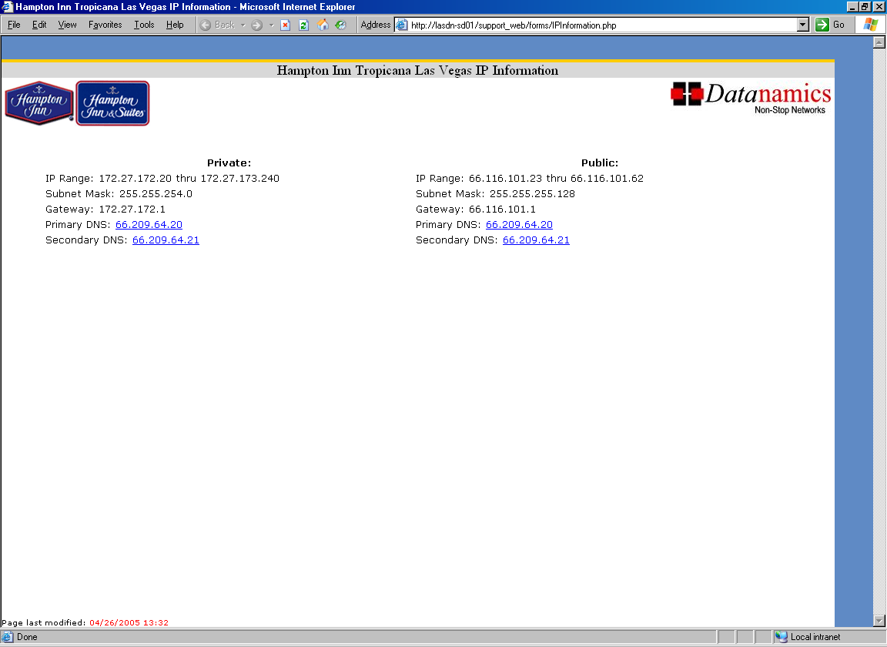

This page contains the following information:

- The IP pools that are available at the hotel.

- If the hotel offers a public IP pool.

- On the newer property pages the ISP information is also listed on this page and not on the property page.

- You always need to double check on the Gateway what pools are active. The support is updated on a constant basis but some information can but outdate. When in doubt ask a second level.

Notes

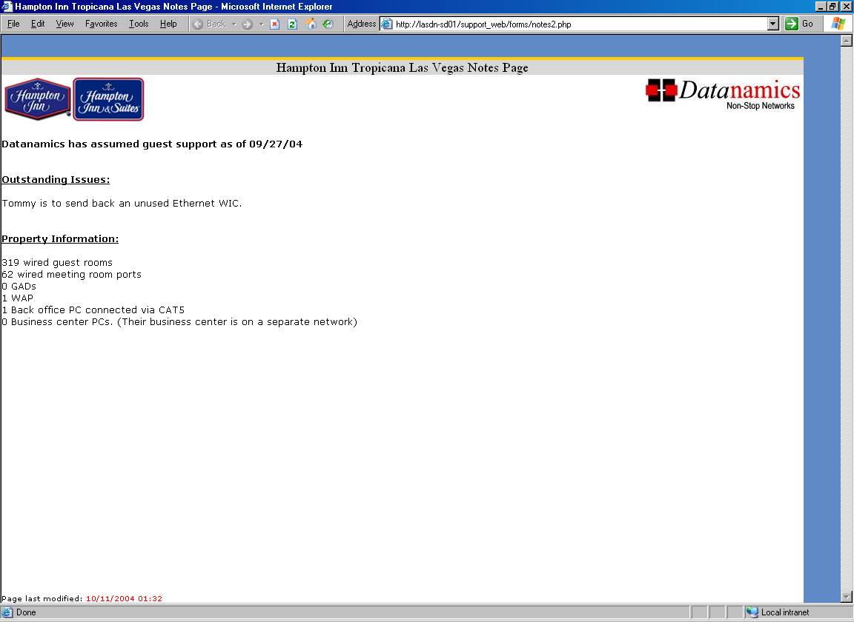

This page contains the following information:

- Any outstanding issues.

- Property information such as the number of wired or wireless rooms.

- The location of the CPE’s at the hotel. (For example see the notes page for the Millenium (New York))

Customer Information

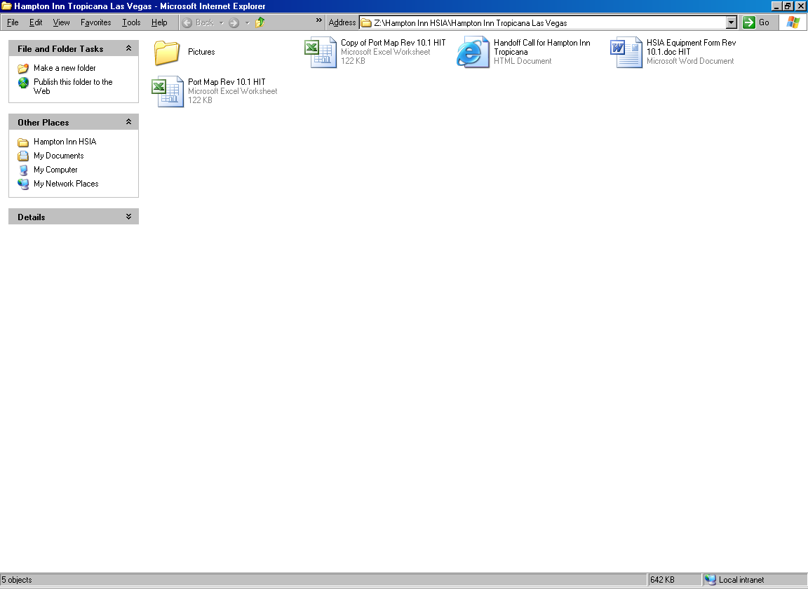

This area is actually linked to a network folder that holds the following information:

- Pictures of the networking equipment at the hotel.

- The port maps for the property.

- The Equipment form.

LEVEL 1 lookups

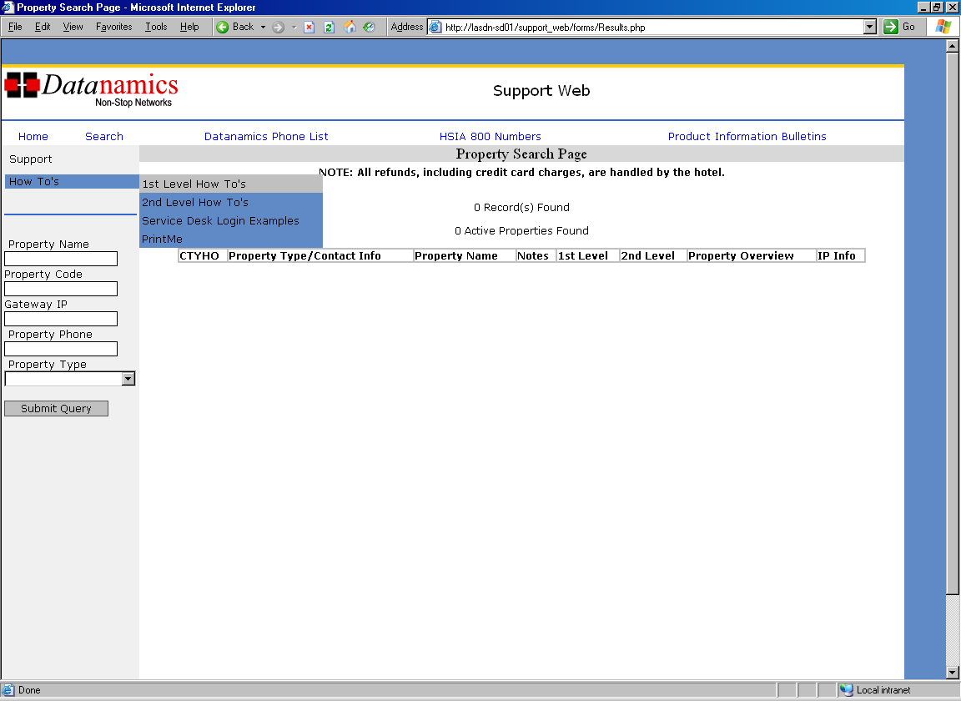

The following are things that you can find in the level 1 how to’s:

- Calls
- USG/HSG Stuff
- Ports
- Billing
- Browser
- Connectivity
- Control Cards
- CPE
- Eleven Wireless
- Email
- Error Messages
- MAC TCP/IP
- Software
- Upgrades
- Wireless
Search

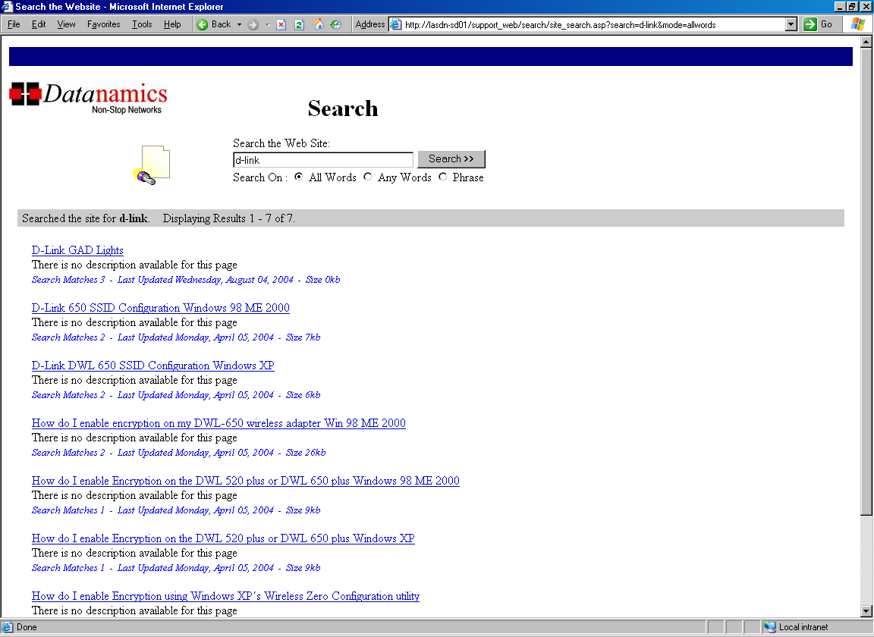

When on the Support web home page you can click on the link Search. You can look up CPE’s, GAD’s, and Wireless utilities for Windows 9x through XP.

LEVEL 1 walkthrough

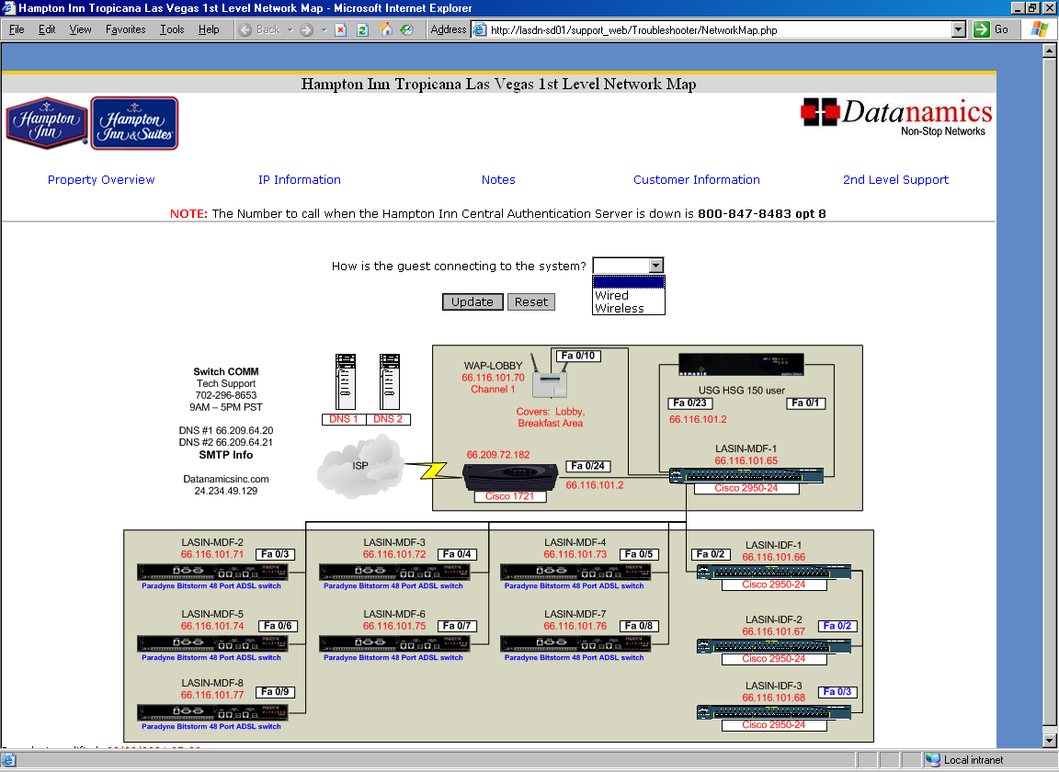

The level 1 walkthrough is located on all property pages. These are meant to be helpful guides to help you troubleshoot a wide verity of issues. You should be checking this area if you feel that you are lost on the call or need help finding a direction to start troubleshooting.

